Shuakbayev Olzhas

Laboratory work 2

Please write your answers to the pdf file for defence:

1. Explain the difference between DDL and DML, give the following examples:
   1. at least 3 DDL commands;

**Create – create to tables.**

Create table table_name(Datatype, column_name[,..])

**Drop – delete table.**

Drop table mines;

**Alter – can change or modify the database structure.**

For ex, to add a new row in the table:

ALTER table table_name ADD row_name row_definition;

* 1. at least 4 DML commands.

Select – to fetch data or values from the database

Insert – command to add new or fresh value to the database

Update – change or update the present/existing data to a newer value inside the database.

Delete – Remove or delete the values or data information from the database’s current table

Merge – merge 2 or more data tables inside database.

1. Write SQL statements to create tables in the figure below:

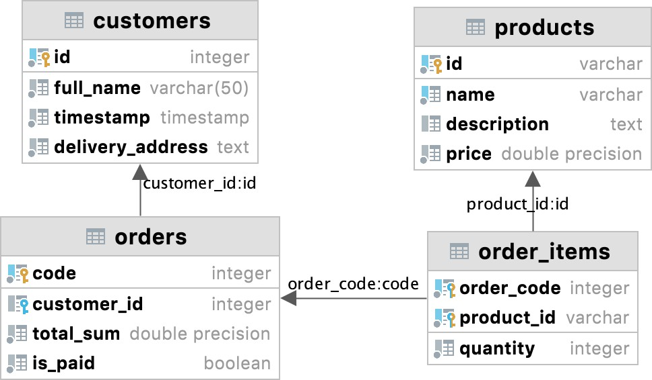

*grey circle - not null, blue column - unique; quantity, total_sum, price > 0*

*ANSWER:lab2_task2.sql*

1. Write SQL statements describing tables with appropriate ***data types*** and ***constraints*** satisfying the following conditions*(maybe you need additional tables to store data* ***atomically*** *and* ***efficiently****)*:
   1. a students table storing data such as full name, age, birth date, gender, average grade, information about yourself, the need for a dormitory, additional info.
   2. an instructors table storing data such as full name, speaking languages, work experience, the possibility of having remote lessons.
   3. a lesson participants table storing data such as lesson title, teaching instructor, studying students, room number.
2. *ANSWER:task3.sql*
3. Give examples of insertion, update and deletion of data on tables from exercise 2.

*ANSWER:lab2_task2.sql*

Note: you can test your queries in datagrip